Ccure 9000: Remote Application Download

- Download the provided application file. If you are using a MAC, you will need to download Microsoft Remote Desktop application to your MAC first.

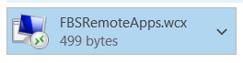

- After you have downloaded the provided application file to your computer, click on the Windows start menu in the bottom left corner of your screen.
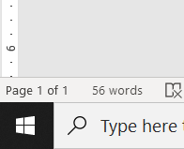

- Locate the folder in the start menu called “F&B Secure Remote Apps (RDAC).”

- Select, by clicking, the Monitoring Station application based on your campus location as follows:

  - Commonwealth Campus Operators & OC Philly/Navy Yard select –
Ccure 9000 SCW Monitoring Station
  - University Park Operators, select - Ccure 9000 SUA Monitoring Station

*Note – if you had Ccure 800 Administration previously, it has been condensed into Ccure 9000 Monitoring only.

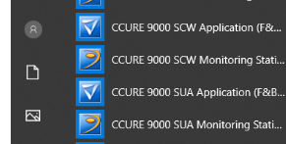

- A Windows Security login box will appear. Sign in using your Penn State credentials (the same for logging into your computer) by adding psu\username and password. Click OK.
  - *If the screen below is asking for you to type your username in add psu\ then your username.* After the first login, the remote application will remember your username as seen below.
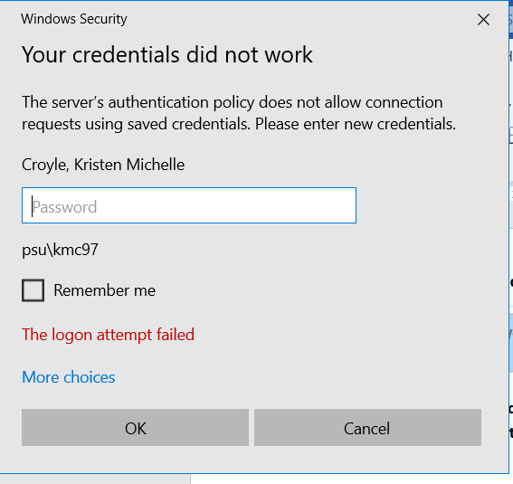

- A RemoteApp blue screen will appear (after a few seconds), click OK.
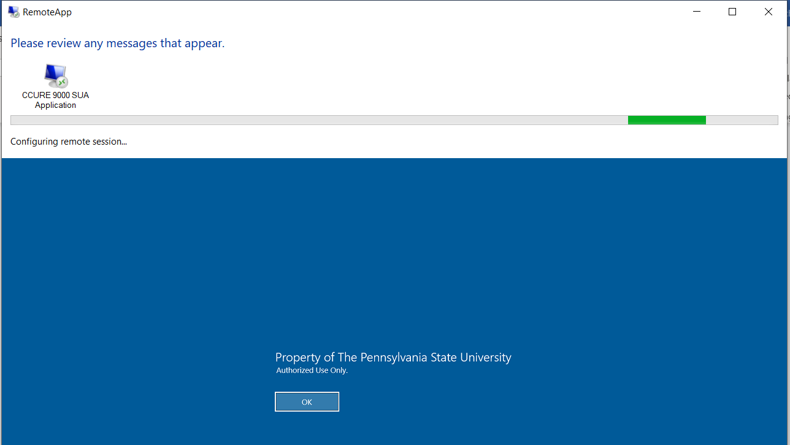

- Ccure 9000 Monitoring will launch on your computer.
