Ccure 9000: Verifying WiQ Controller or Portal Online Status (HFS)

If a WiQ door is not operating as programmed (refusing personnel with appropriate access, operating as “card only” when programmed as “card and pin”, etc.), you can perform a full download IF the door is online. If the door is offline, first anti-tamper to bring the door online. To verify WiQ controller or portal online status, follow the below stels

- In Ccure 9000 Monitoring left click on "Dynamic Views."
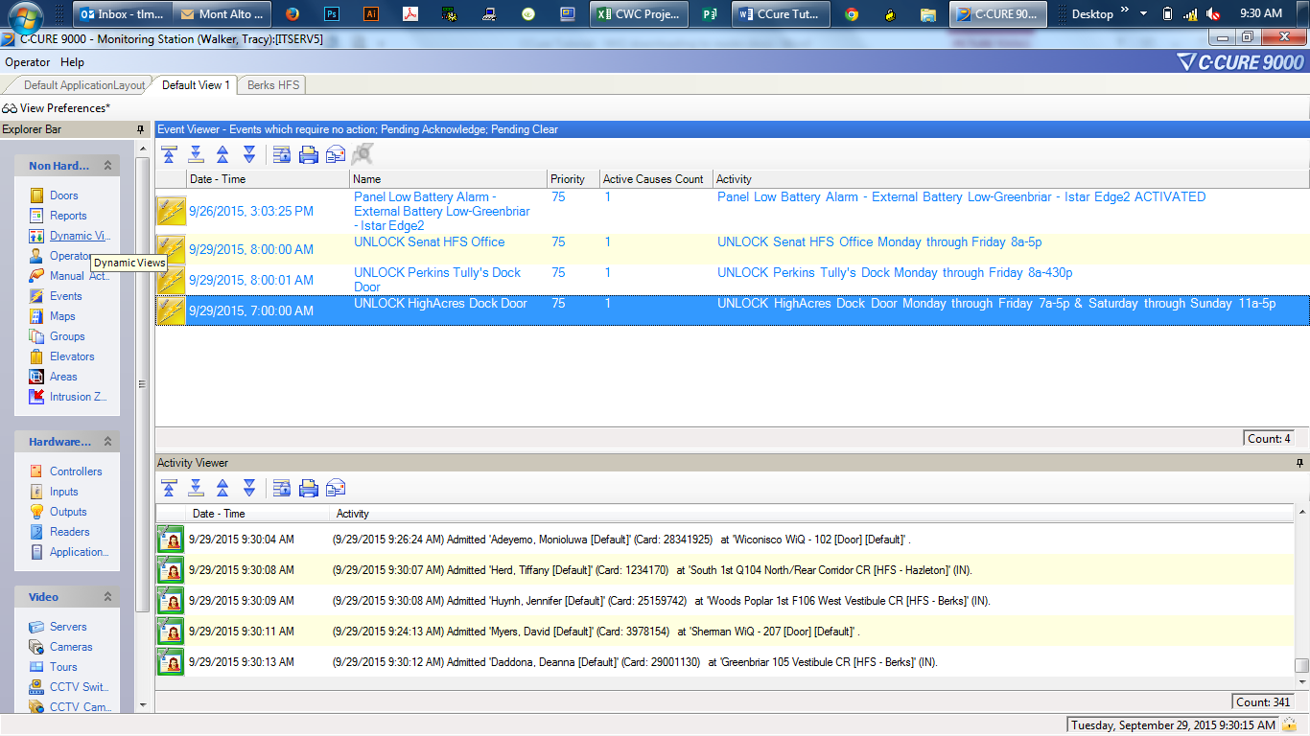

- A dialog box will appear. Double-click "WiQ Controller" or “WiQ Portal.”

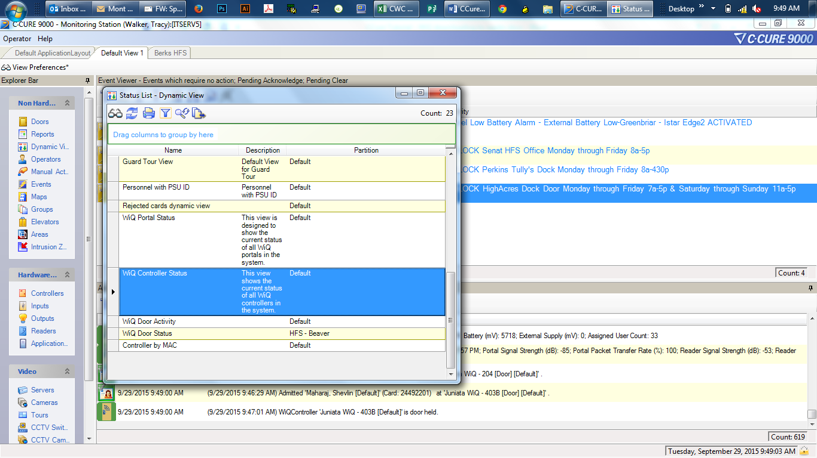
- You can add columns by right-clicking on a column title and selecting “More Columns” then choosing the columns you want. Make sure “Online” is included so you can ensure the door is online.
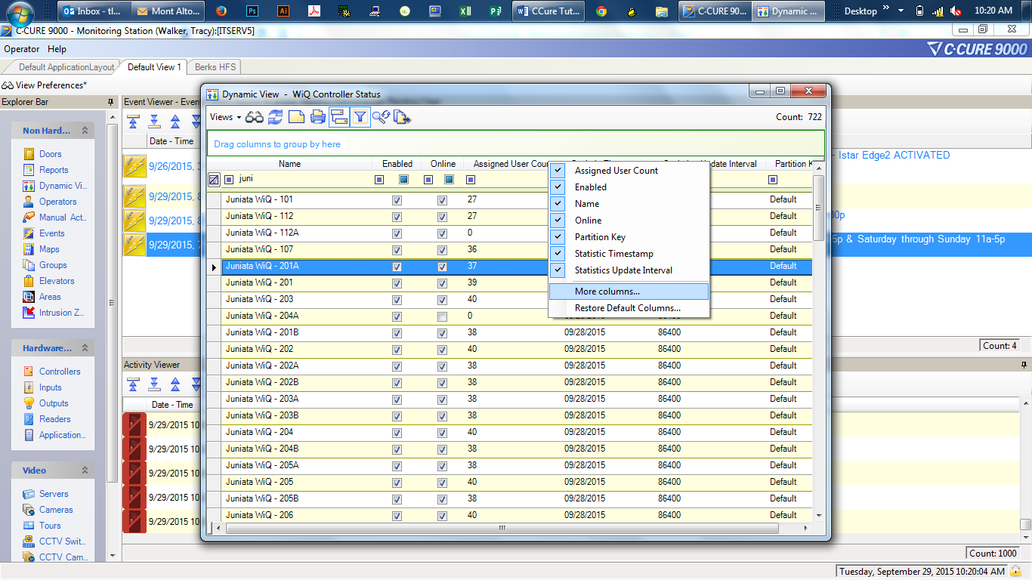
- Choose “Filtering” to easily find the controller/portal you need.
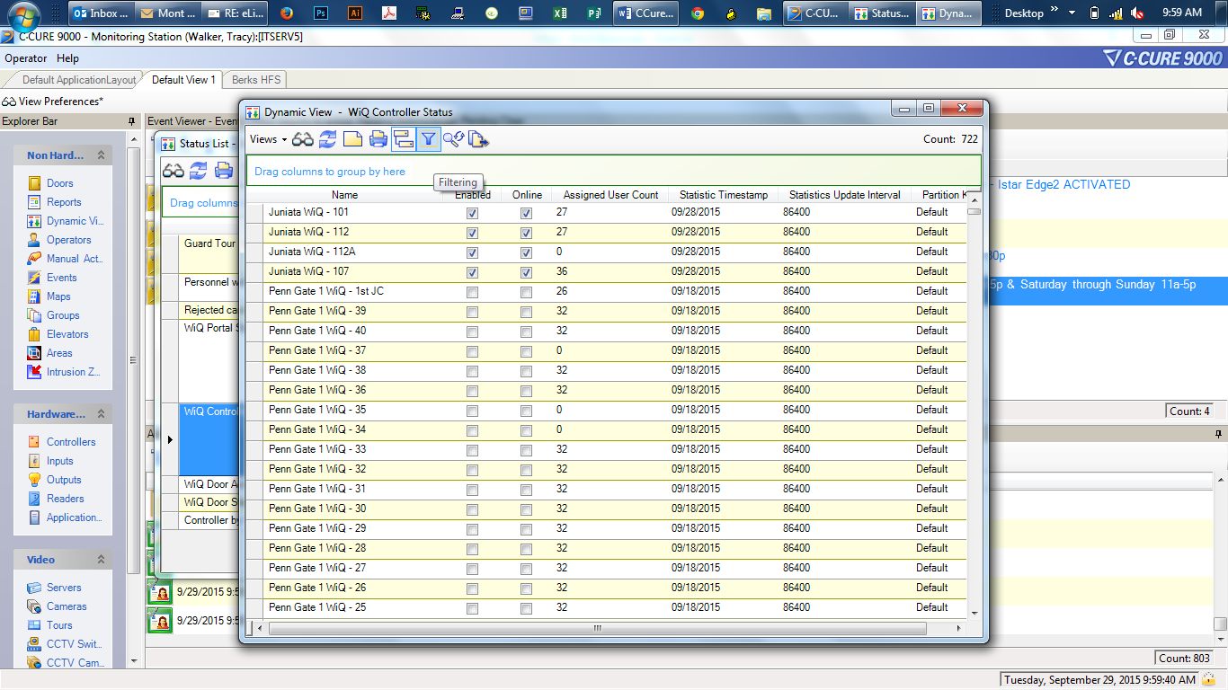

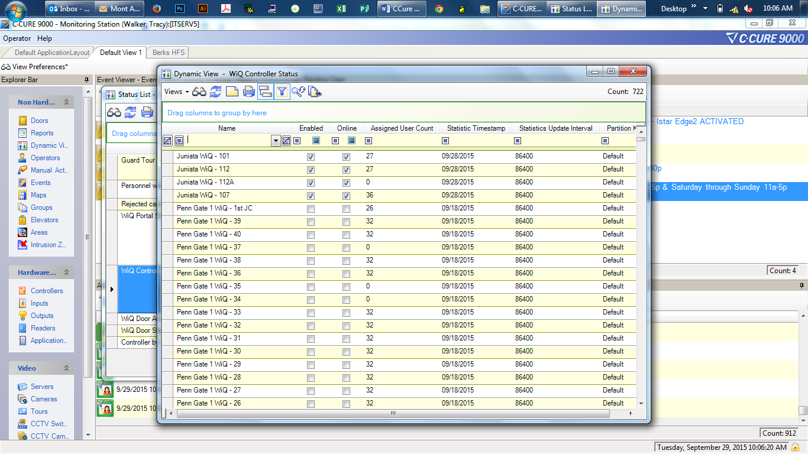
- Left click on "Name" and begin to enter the controller/portal name.

- Identify if the check box in the “Online” column is checked. If not, controller/portal is offline. An Anti-Tamps should be performed at the controller or a power cycle at the portal.


