Ccure 9000: How to Review an Event

- In Ccure Monitoring Station select “Dynamic View” in the right-side Explorer Bar.
- A dialogue box will appear, select “Event View” by double clicking.
- Find the event to review via the filter button in the top tool bar or by scrolling through the list.
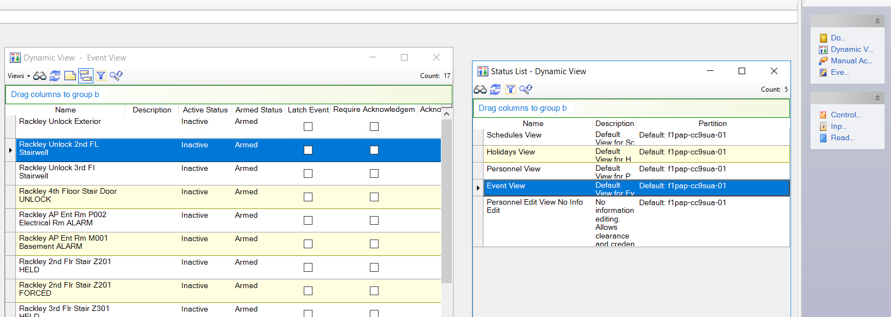
- Double click on the event you want to review, and the event will open.
- To review the schedule associated with the event, reference the Scheduling section on the General tab. The schedule name in the “Activate on Schedule” line is the associated schedule.
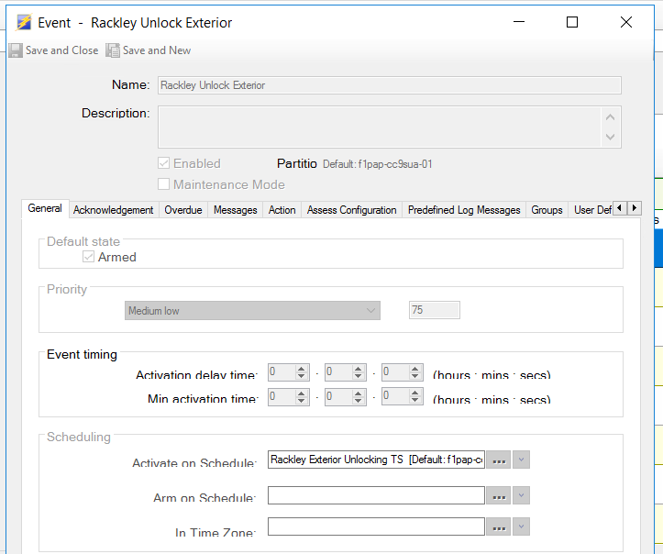

- To review the actions the event will take on the associated schedule, click on the “Action” tab. The actions listed on this tab will enable when the schedule is active.
