Ccure 9000: How to Look Up Personnel

- In Ccure Monitoring Station select “Dynamic View” in the right-side Explorer Bar.
- A dialogue box will appear, select one of the following based on the information you have and then double click on your selection:
  - Personnel with Name
  - Personnel with PSU ID
  - Personnel with User ID

- Place the individual’s information in the “Value” box (be sure there is not a space after the information). Click Run.
  - You can search for multiple individuals by changing the “Filter Type” to “In List.” Then click in the Value box and select the … button. This will populate a new window where you will enter your first entry, hit tab, add your second entry, etc. Once complete, click OK.

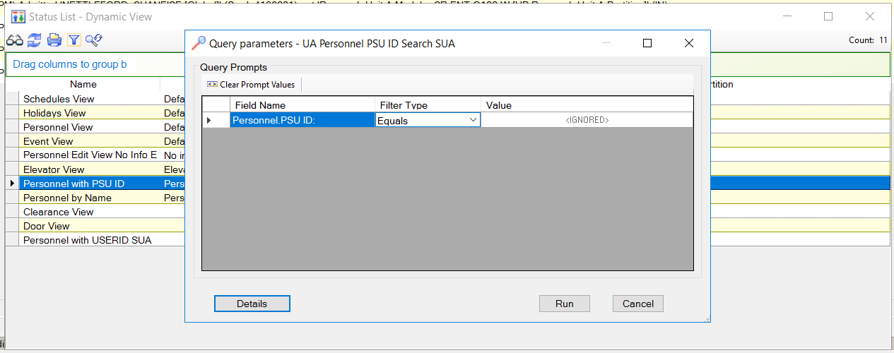

- Double click on the record that populates, and the record will open.

- On the personnel record you can view information such as:
  - Name (first and last)
  - If their record is disabled – General tab, Options section
  - Card number – Credentials tab
  - Card Access Clearances – Clearances tab
  - Custom Card Access Clearance – Custom Clearance tab
