Ccure 9000: Downloading to a WiQ Controller (HFS)

If a WiQ door is not operating as programmed (refusing personnel with appropriate access, operating as “card only” when programmed as “card and pin”, etc.), you can perform a full download IF the door is online. If the door is offline, first anti-tamper to bring the door online – the door must be online for a download to take effect.

- In Ccure Monitoring Station left click on "Dynamic Views.”
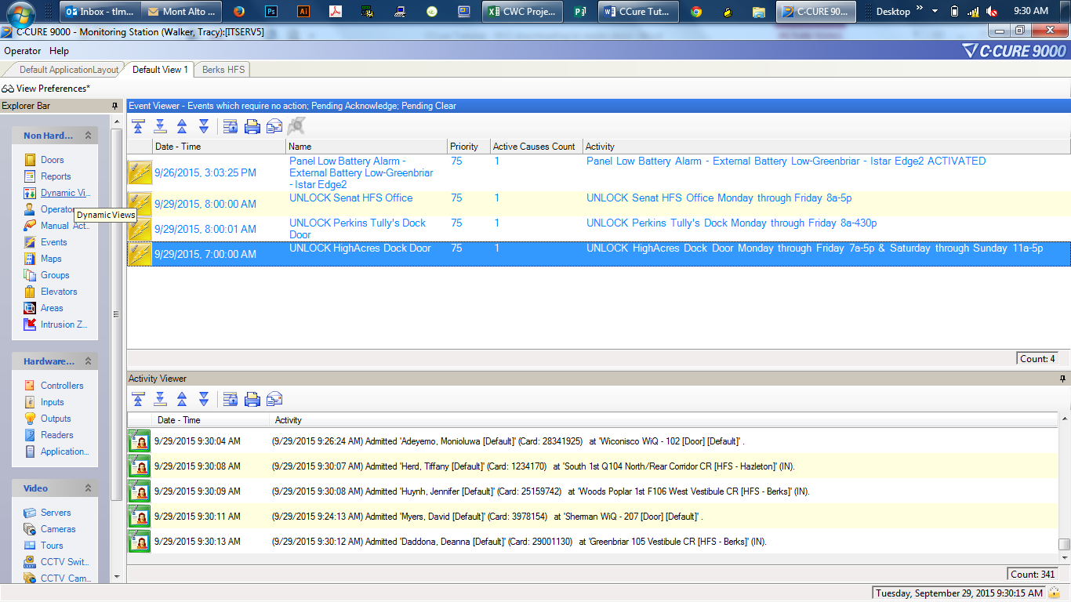

- A dialog window will appear. Double-click "WiQ Controller."

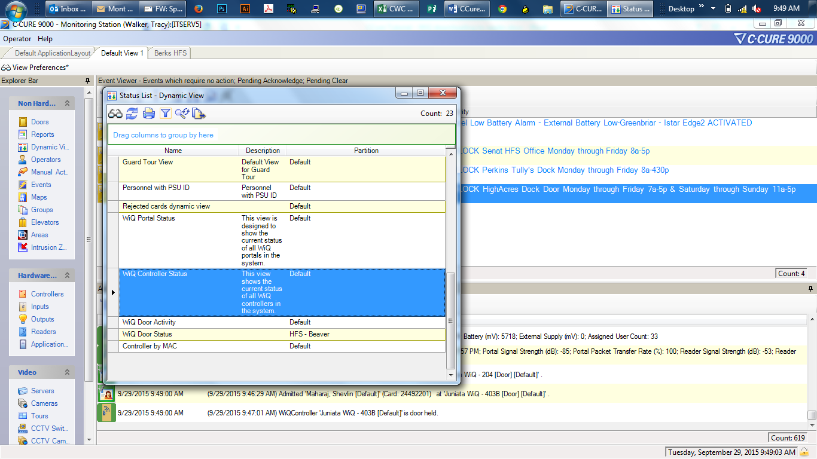
- You can add columns by right-clicking on a column title and selecting “More Columns” then choosing the columns you want. Make sure “Online” is included so you can ensure the door is online.
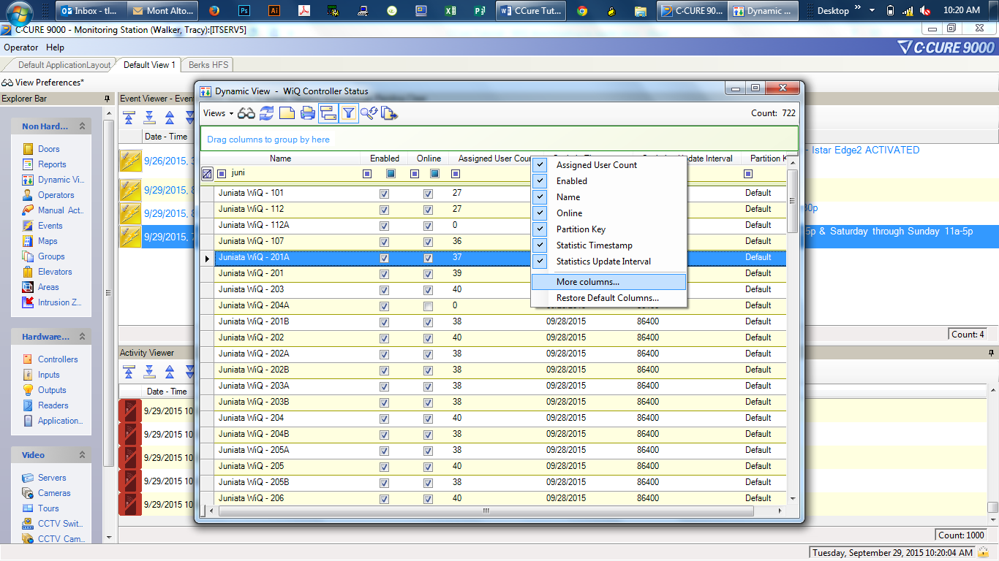

- Choose “Filtering” to easily find the door you need.
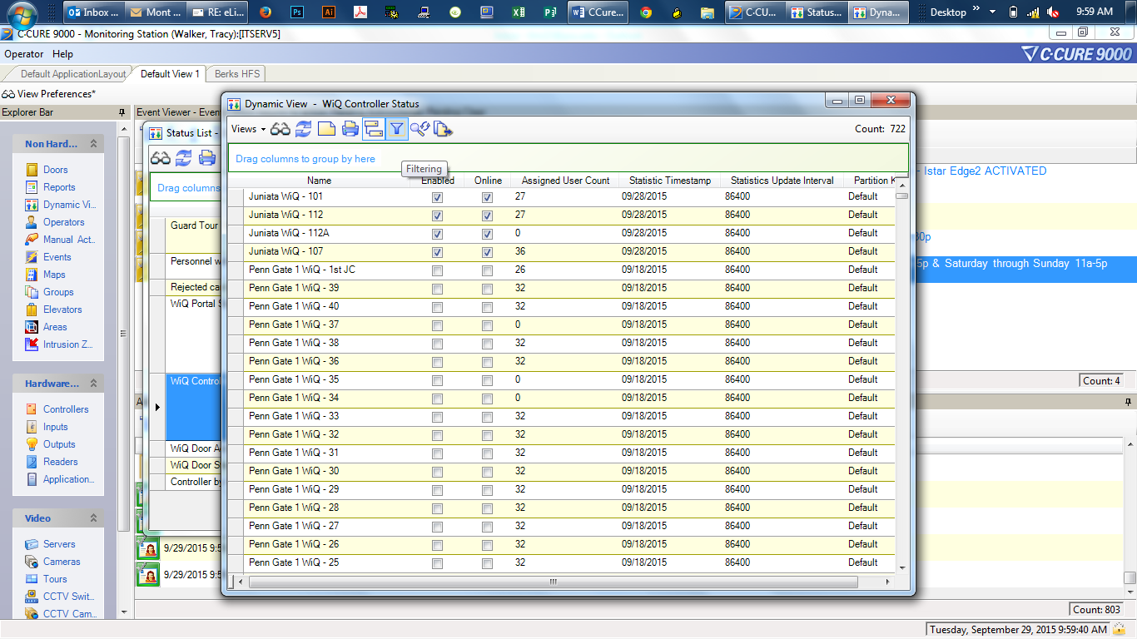

- Left click on "Name" and begin to enter the door name.
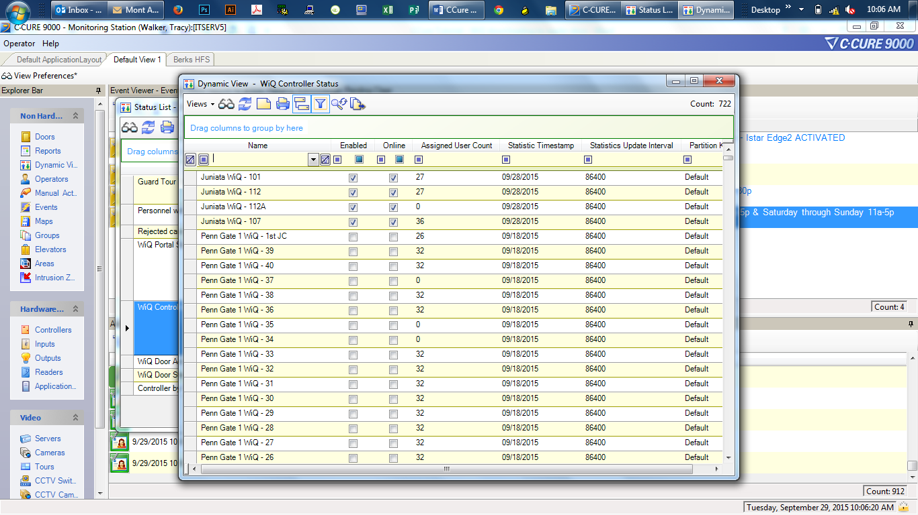
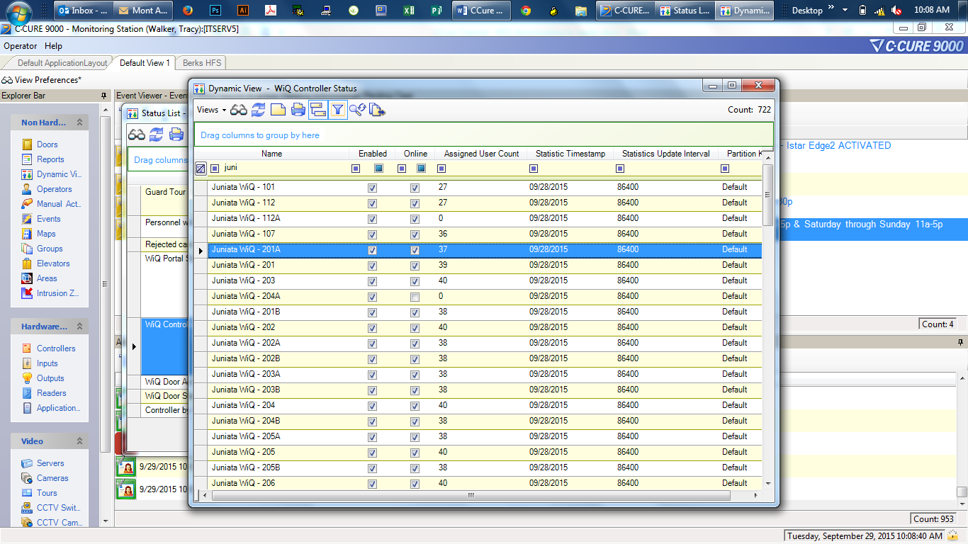

- Left click on the desired door to highlight.
- Right click on door and choose “Full Download.”
