Ccure 9000: View/Edit Personnel Pin Number

- In Ccure 9000 Monitoring Station select “Dynamic Views.”
- Select “Personnel View.”
- Select filter .
- Search for personnel and double click.
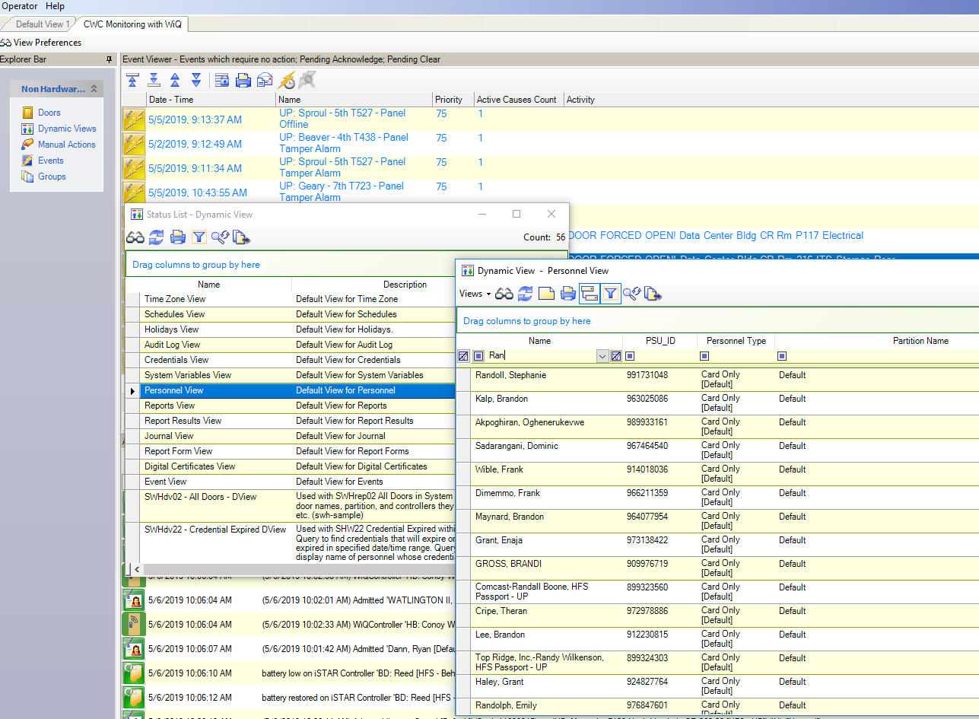

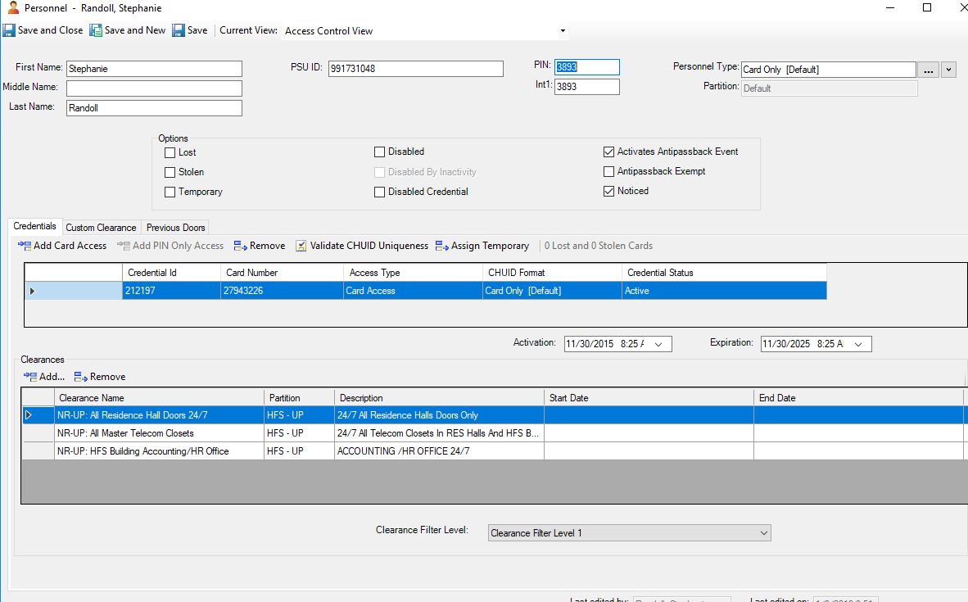
Pin code is listed under PIN: and Int1:

- When changing a PIN, you must change it in both PIN and Int1 boxes. Remember that the code cannot begin with a (0) zero.

