Ccure 9000: Disable Door Forced/Held Alarms

- In Ccure Monitoring Station select Doors in the right-side Explorer Bar.
- Find the door to perform the disable/enable function on via filter button in the top tool bar or by scrolling through the list.
- Once door is located select the door by clicking once on the row (will turn blue), then right click.
- From the menu, choose “Disable Door Forced Alarms” or “Disable Door Held Alarms.”
- A Manual Auction box will pop up:

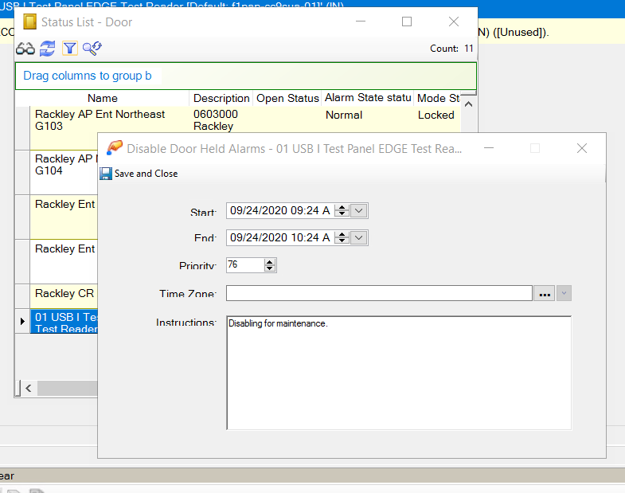

- The start and end time are defaulted to one hour; however you can change the date and time and schedule in advance.
  - Do not change Priority or Time Zone.
  - Enter a short description or note under Instructions (Ex. Unlock for Student Event).
  - Click Save and Close in the upper left.
- Your manual action has been scheduled. If you need to change, view or delete this at any time Click on Manual Actions in the Explorer Bar (refer to training: How to View or Delete your Manual Actions). The Manual Actions dialogue box will show all scheduled or active manual actions.

