Ccure 9000: Batch Upload Requests

When assigning a clearance to multiple ID cards, you will need to request a Batch Upload be completed by the Physical Security Office. You will utilize an Excel spreadsheet to provide the individuals PSU ID’s or User ID’s along with the clearance name to assign.

Best Practices:
- Request a clearance in CCure prior to sending the batch upload.
  - Submit a ticket via the Physical Security website (https://www.police.psu.edu/report-issue-or-make-request) using the form “Request a New Ccure Card Access Clearance or Modify an Existing Clearance.”
- Request to delete any old/expired clearance(s).

Batch Upload Guidelines:
- An upload can be completed when adding a clearance to 25 or more ID cards. Anything less than 25 should be handled by the local Access Coordinator in Ccure 9000 Monitoring.
- The spreadsheet will need to list either the PSU ID or User ID in column A (PSU ID is preferred method) and the exact clearance name in CCure in column B.
  - USER ID – Each person with an PSU Access Account is assigned a unique username of three letters paired with a series of digits (example, xyz1234)
  - PSU ID - Penn State Identification nine-digit number.
Examples of correct Excel spreadsheet format:

PSU ID example: USER ID examples:
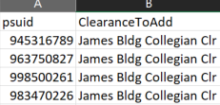
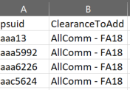

Once complete, please upload the formatted document(s) by submitting a ticket via the Physical Security website (https://www.police.psu.edu/report-issue-or-make-request) using the form “Request a Ccure Batch Upload (Add or Remove Access).”

