CCURE Training Series: #6 – Batch Upload

When assigning a clearance to multiple ID cards, you will need to send an Excel spreadsheet of the individuals PSU ID’s or User ID’s along with the clearance name to the Office of Physical Security for a batch upload.

Best Practices:
- Create a clearance in CCure prior to sending the batch upload.
  - If you need assistance with creating a clearance, refer to the creating clearances job aid of the Physical Security webpage (job aide #3).
- Delete the any old/expired clearance(s) after the upload is completed.

Batch Upload Guidelines:
- An upload can be completed when adding a clearance to 25 or more ID cards. Anything less should be handled by the local Access Coordinator.
- The spreadsheet needs to list either the PSU ID or User ID in column A (PSU ID is preferred method) and the exact clearance name in CCure in column B.
  - USER ID – Each person with an PSU Access Account is assigned a unique username of three letters paired with a series of digits (example, xyz1234)
  - PSU ID - Penn State Identification nine-digit number.
Examples of correct Excel spreadsheet format:

PSU ID example:
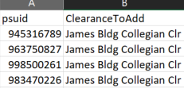

USER ID examples:
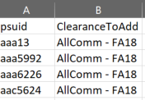

Please send the spreadsheet along with any instructions to:
physicalsecurity@PennStateOffice365.onmicrosoft.com

