CCURE Training Series: #5 – Reports & Audits

Reports are valuable tools that can be used to help audit a clearance as required by Procedure SY2001.
Best Practices:
- Never add a clearance that you don’t “own” to any user without following the SY2001 procedure!
- Naming conventions for clearances serve to identify who “owns” and is responsible for maintaining any given clearance. The recommended naming convention within the College of Engineering shall be:

“Building Name – ADMIN UNIT – Name of Clearance”
Where:
“Building Name” = the common name of the building being controlled (i.e. Hammond)
“ADMIN UNIT” (in ALL CAPS) = Department / Unit responsible for maintaining the clearance (can be abbreviated so long as the abbreviation is understood by all Access Coordinators)
“Name of Clearance” = descriptive name of Clearance (i.e. “All Access” or “Room 123” or “Shops”)

Creating a NON-PRINTABLE user summary by clearance (good for low numbers of users/clearance):
- From the Administration Client home page, click “Query” under the “Personnel” tab.
- Click the “Clearances” tab to list the Available Clearances, as shown below:

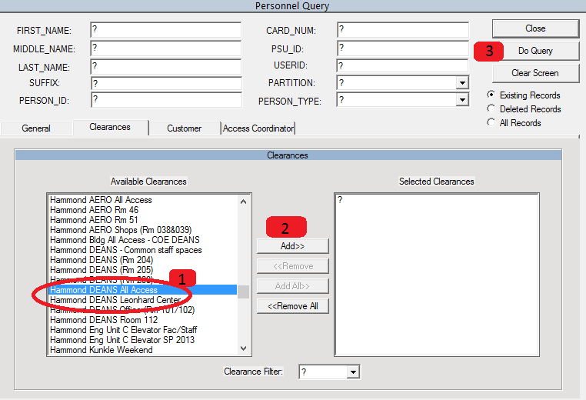

- Highlight the desired clearance by clicking on the clearance name (#1 above).
- Select the highlighted clearance by clicking the “Add>>” button (#2, above). The clearance will move over to the box on the right.
- Click “Do Query” to run (#3, above). The results will be shown in a new window, as below.
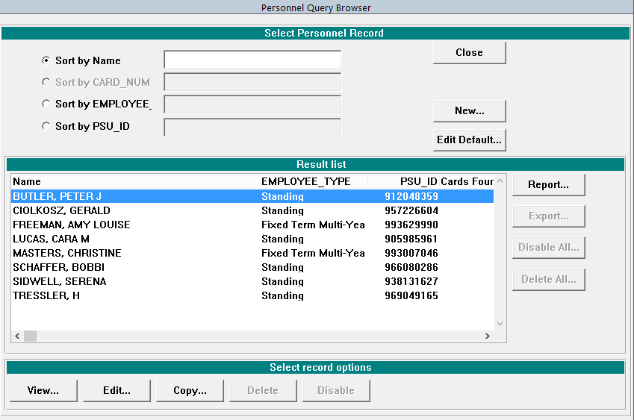

Creating a PRINTABLE / DOWNLOADABLE Clearance report:
- From the Administration Client home page, Single Click “Reports” to open a drop down menu.
- Hover over “Personnel” so that the sub-menu opens and click “personnel” to open new window as below:

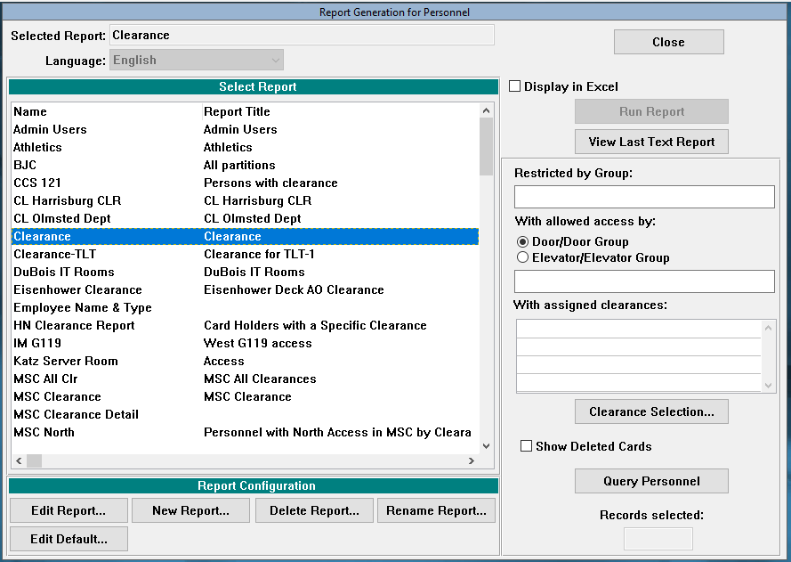
3
2
1

- The look for the line “Clearance Report” and highlight that line. Check the box “Display in Excel” (#1, above), then click “Query Personnel” (#2, above). A new “Personnel Query” window should open.

- Select the desired clearance using the same process as described on the previous page.

- You should be directed back to the original “Report Generation for Personnel” window, except that now the “Run Report” button should not be faded out (#3, above). Click “Run Report.”

- The report should open in Microsoft Excel. (Note: you may receive a security warning from Excel as it opens. Just accept the warning to finish opening the report.) The Excel report data can be sorted, filtered, save, cut/paste, etc., as needed, to help you complete the audit. However, any additions or deleted, will need to be made manually in CCURE like normal. (See CCURE Training Series #2 – Assigning & Deleting Clearances).

Note: Additional report configurations / features are available but are not discussed here. Please contact the COE Safety & Security Coordinator or a CCURE Administrator for additional setup assistance if needed.

