CCURE Training Series: #4 – Creating / Editing Events

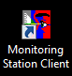
Events are single-use overrides to an existing door schedule and are programmed through the Monitoring Client (versus the Admin Client)

Best Practices:
- Never delete or edit events for areas not under your control unless directed to do so by an authorized person. This is especially important in shared buildings where multiple departments share a common partition.

To create an Event, (starting from the Monitoring Client HOME screen):
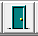
- Click the green “Door” button from the toolbar.

The following screen should appear (Doors listed will correspond the Partitions to which you have access and may differ from that shown below):

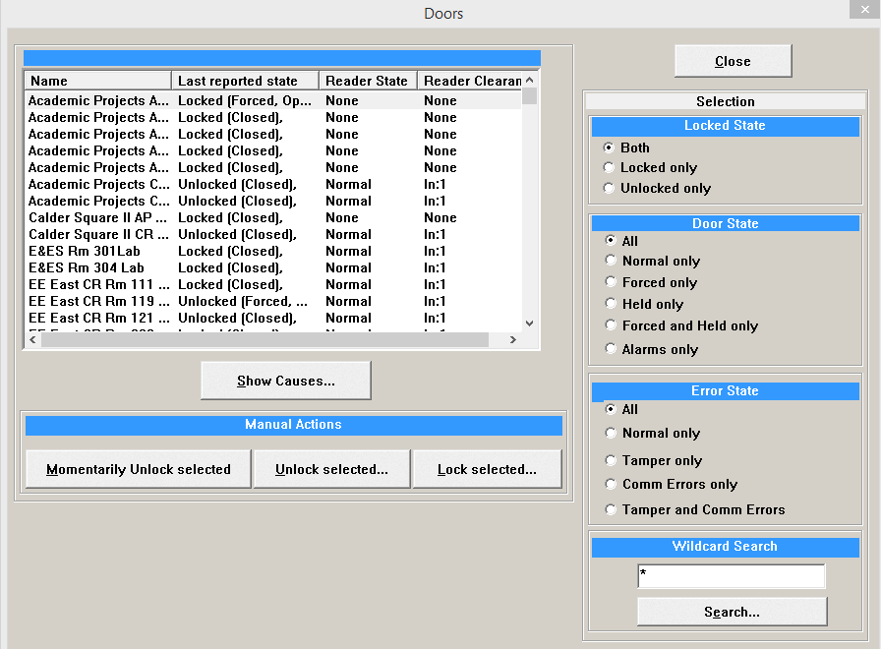

- Highlight the door you wish to schedule and select the desired Event type, as appropriate: “Unlock Selected” or “Lock Selected”
(Note: This may also be accomplished by Double Clicking on the desired function: “Unlock” or “Lock”
- NOTE: You may also momentarily remotely unlock a door by clicking “Momentarily Unlock selected” which will unlock the door for a few seconds. THIS SHOULD ONLY BE DONE WHEN YOU KNOW FOR CERTAIN WHO IS ENTERING THE DOOR IN QUESTION so as to prevent unauthorized entrance.
- The following screen should appear:
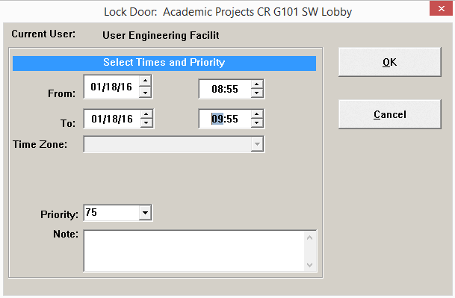

- Adjust the dates & times and click “OK”
(Note: The Priority field is only used to establish a ‘hierarchy’ of commands in the instance where conflicting programming instructions are present. “75” is normally sufficient and should not be increased without justification.)
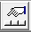
To View / Cancel an Event:
- Click the “Manual Actions” button in the toolbar:
The following screen should appear:
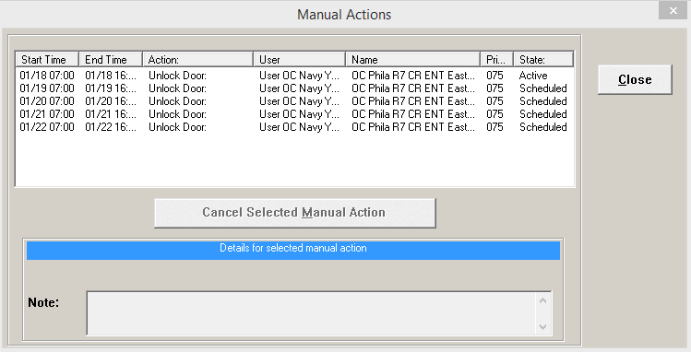
- Highlight the Event you wish to Cancel and click “Cancel Selected Manual Action”
(Note: You cannot edit an event, but only delete and create a new event.)

