CCURE Training Series: #3 – Creating / Editing Clearances & Time Specifications

Best Practices:
- Never delete or edit clearances for areas not under your control unless directed to do so by an authorized person. (This ability should be disabled for partitions not under your control.) This is especially important in shared buildings where multiple departments share a common partition.
WHEN IN DOUBT, CREATE YOUR OWN CLEARANCE (and name it appropriately)!
Creating Clearances:

- Select Configure from the tool bar
- Select Clearance

Clearance Selection Dialog Box will appear

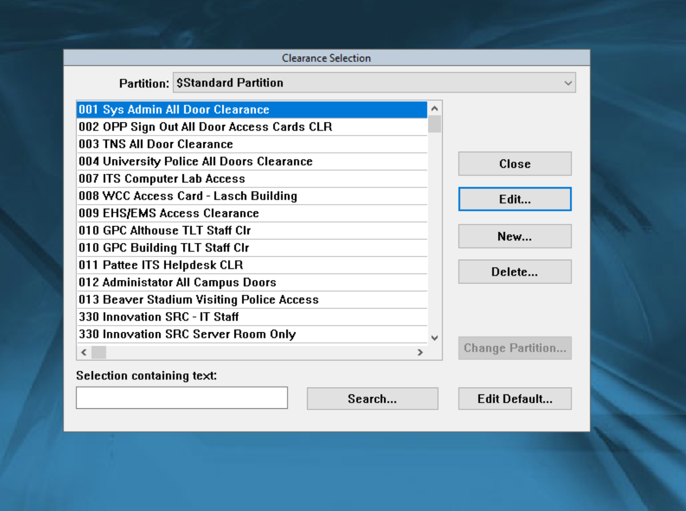
- Select or make sure you are in the correct partition
- Select New

The Configure Clearance Dialog Box will appear.

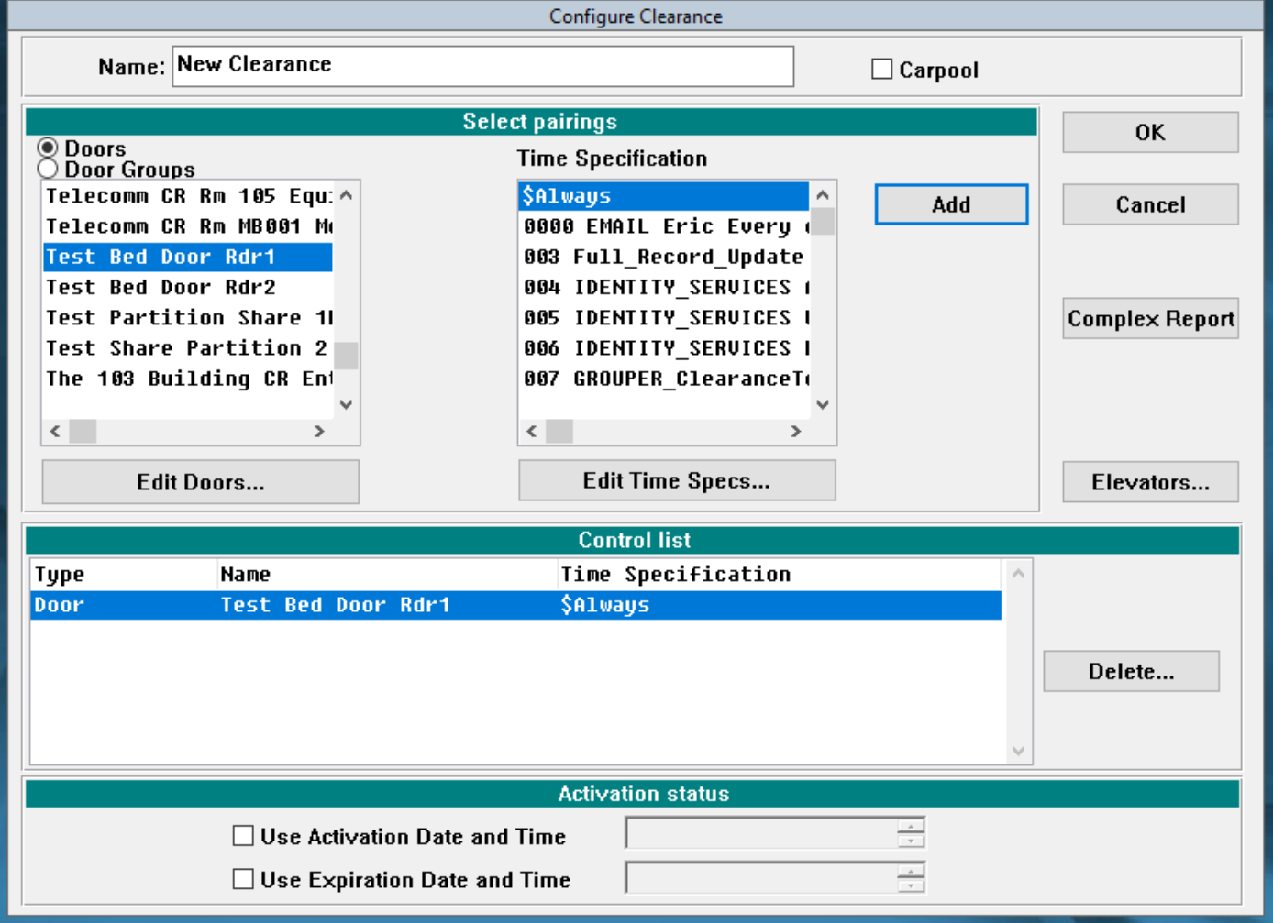
- Name the Clearance
- Select the Door and Time Specification pairing
- Click Add
- Selected pairings will appear in the Control List
- Select OK button when complete
If there are no beginning or end dates/times listed in Item #3, Activation Status, then the Clearance is permanent – active immediately and continuing to be active until deleted or edited.

Useful Information:
- Remember to name the Clearance such that it is easily recognized by any user (Recommended Naming Convention = Building Name – Admin Unit – Clearance/Room Name – Time (if temporary)
- The Control List box shows the actual door/time combinations controlled by the clearance and is created by combining the door with a time specification. More than one combination can be present in the Control List.

To Edit a Clearance:
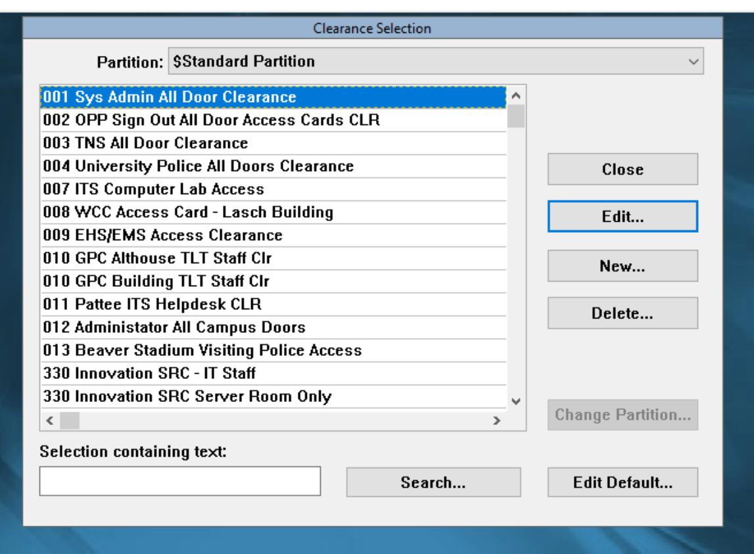
- Highlight the desired clearance from the left column by clicking it once.
- Click the Edit button and the Configure Clearance dialog box will open to make the desired changes.
- Please note, changing a clearance (s) will automatically update it for everyone who currently holds that clearance.

Time Specification – Creating and Modifying Times

- Primary uses – Unlocking of doors (Requires additional Event)
- Restricting access based on time of day (When paired with a door in a Clearance)

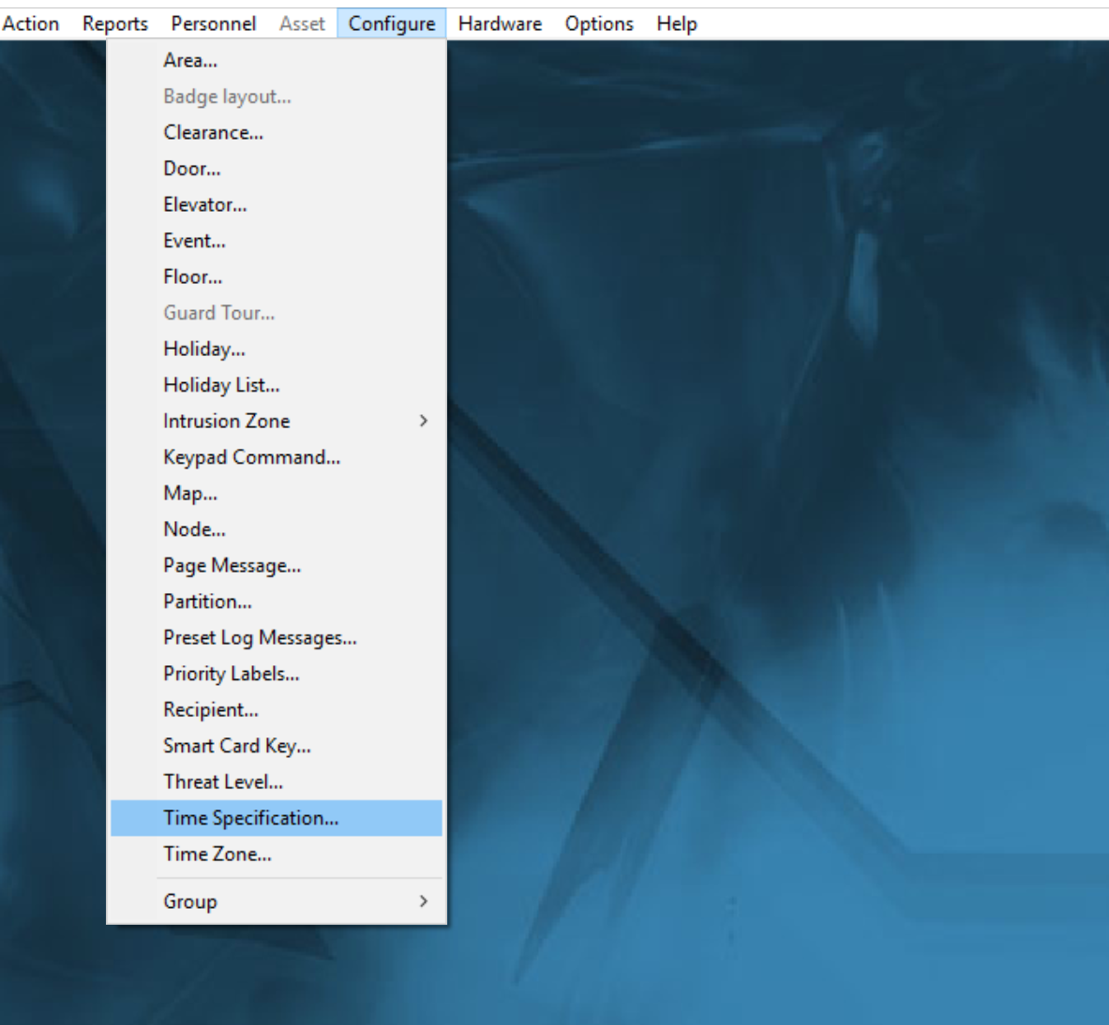
- From the Configure drop down menu select Time Specification.
- This can also be done from the Configure Clearance dialog box under the time specification clearance. Just highlight the clearance and select Edit Time Spec.

Time Spec Selection Dialog Box
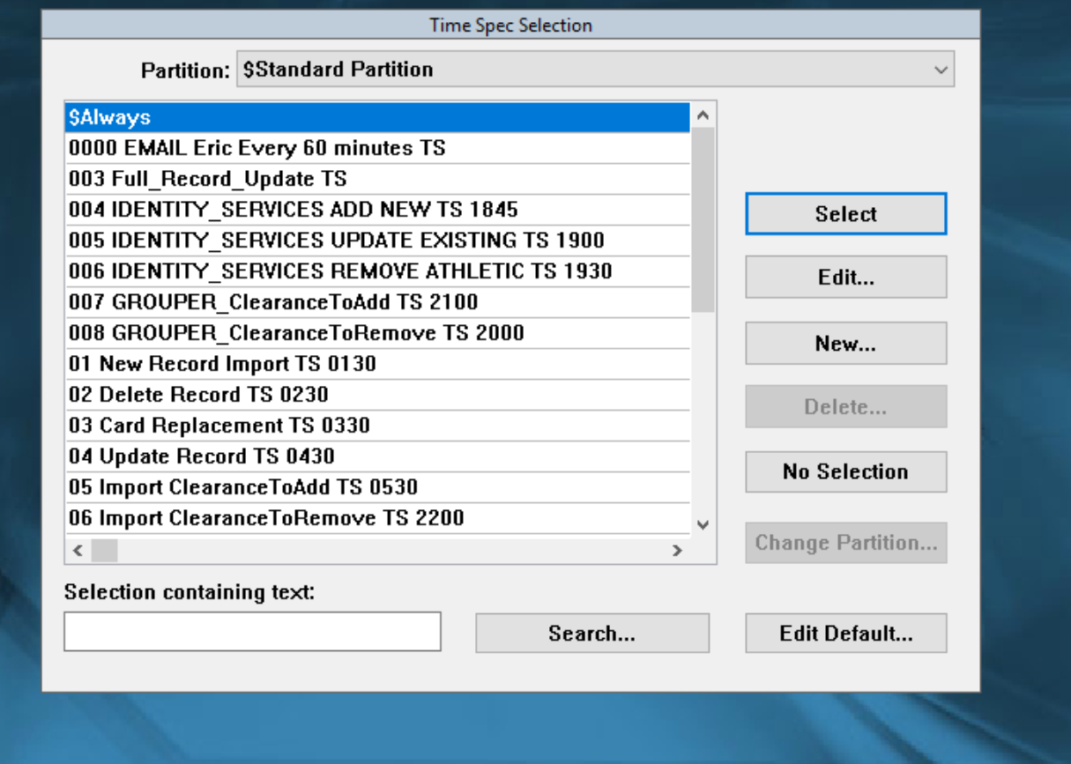
- Select the correct partition
- Click New

Note: if editing a time spec, highlight the clearance and select edit

Time Specification Dialog Box

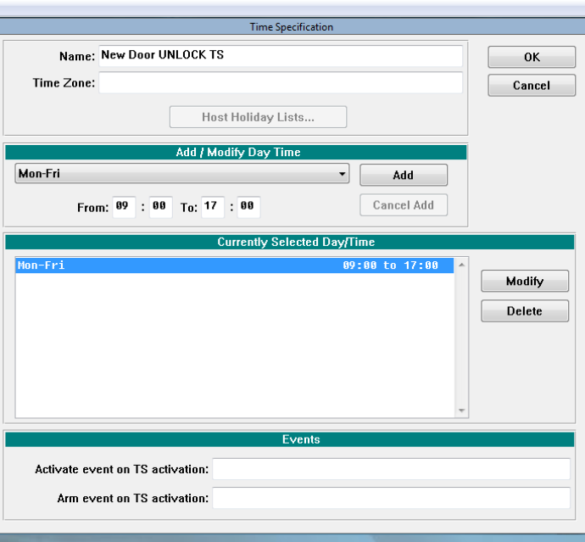
- Name the Time Specification
- Select Add/Modify Day Time drop down menu
- Select the desired day(s)
- Click Add
  - You can also modify/delete on this screen
- Click OK

Note: Unlocking doors requires a system event. Please contact the Physical Security Office for assistance.

Changing a Time Spec (s) will automatically update every clearance currently using the Time Spec.

