CCURE Training Series #2 – Assigning & Removing Clearances

The most common task that an Access Coordinator will need to perform is Assigning or Removing Clearances:

To Open a Personnel Record:
- Search for the desired individual using one of the Query functions under the “Personnel” tab.
The following window should open:

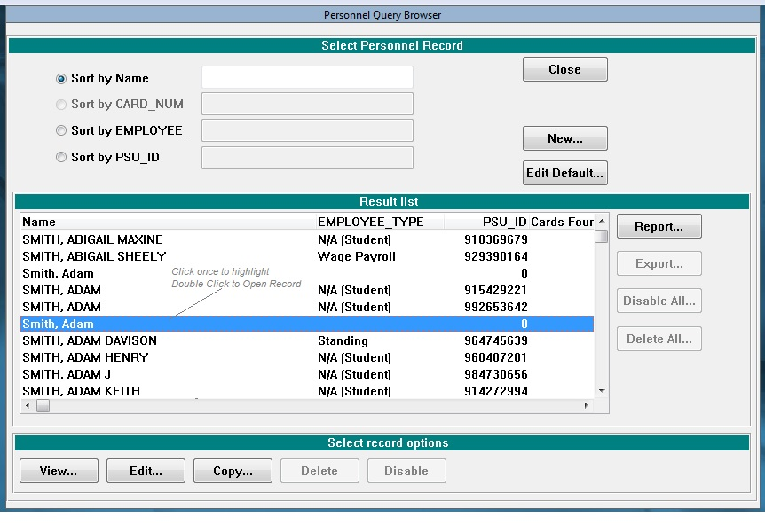
- Double Click to open the desired individual’s Personnel Record:
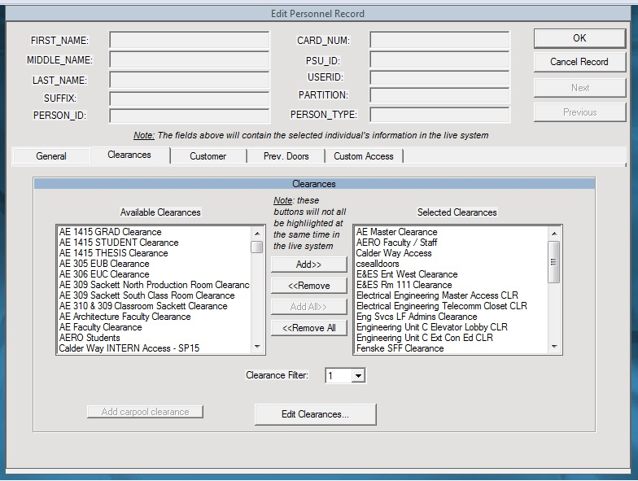

The Clearances listed in the LEFT column are the clearances available to you (as the Access Coordinator) based on the CCURE Partitions that have been assigned to you.

The Clearances listed in the RIGHT column are the clearances currently assigned to the user’s ID Card.

To Assign a Clearance:
- Highlight the desired clearance from the LEFT Column by clicking on it
- Click the “Add>>” button
- The clearance should now appear in the RIGHT column
- Click the “OK” button to exit the Personnel Record and activate the clearance for the cardholder

To Remove a Clearance:
- Highlight the desired clearance from the RIGHT Column by clicking on it
- Click the “<<Remove” button
- The clearance should now appear in the LEFT column
- Click the “OK” button to exit the Personnel Record and deactivate the clearance for the cardholder

(Alternatively, you can click “<<Remove All” to remove all of the clearances from a cardholder’s ID Card)

Helpful Tips:
- Remember to click “OK” after assigning/removing a clearance in order to activate the transaction.
- Up to forty (40) clearances may be added to a single card. If the card is running out/low on clearance “slots”, multiple doors may need to be combined into a single clearance that can be assigned to an individual.

Best Practices:
- Always verify the correct individual using TWO identifiers when assigning or deleting clearances.
- Never delete clearances for areas not under your control unless directed to do so by an authorized person. (This ability should be disabled for partitions not under your control.) This is especially important in shared buildings where multiple departments share a common partition.

See CCURE Training Series #1 – Queries for assistance, if needed

