CCURE Training Series: #1 – Queries

The most common way to Search to find information in the database is a Personnel Query:
- From the main System Administration window, click “Personnel” and scroll down to “Query”.

From the Personnel drop down menu- Select “Query”

Other options are available but the “Query” function works the best.

This will open the “Personnel Query” form

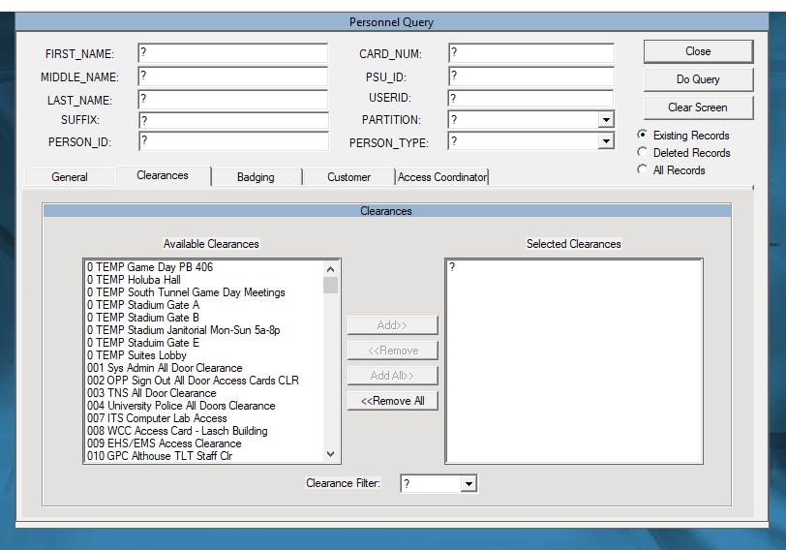
The following window should open:

2
1
3

4

Most Common Types of Queries: (any field containing a “?” can be queried – then click “Do Query”)

- NAME - as it appears on the ID card – use of the “WILD CARD” may be needed
NOTE: * is your “WILD” CARD”. It is especially useful in the NAME fields

- USER ID – This is the best practice to ensure you get the correct person. Search using CAC ID- This is your Penn State User ID- “kmc97”

- PSU ID – nine digit number, bottom of ID card (no spaces or hyphens)
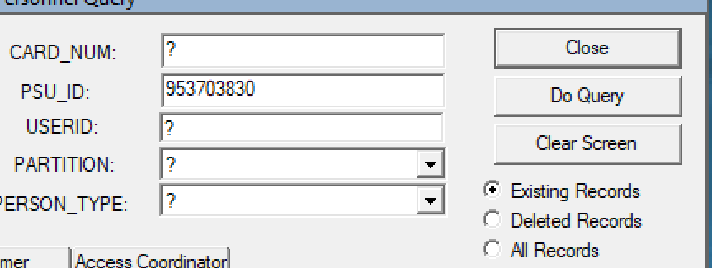

- Clearances – search for all individuals assigned a certain clearance

Helpful Tips:
- Be sure the “?” is in every Field where you are not entering a value. A blank box equals a (SPACE)

Best Practices:
- Whenever possible, search using Fields with NON-DUPLICATED VALUES such as USERID, PSU_ID, or CARD_NUM (or FULL_CARD_NUMBER)
- Always verify the individual using TWO identifiers, especially when searching by NAME

